HematoVision: Advanced Blood Cell Classification Using Transfer Learning
Introduction
TeamID: LTVIP2026TMIDS65904
- Team Leader : Veeranki Nandini
- Team member : Ande Yagnesh
- Team member : Chebrolu Padmavathi
- Team member : Dachepalli Nikhitha

OBJECTIVE:
HematoVision is designed to build a high-performance and computationally efficient system for blood cell image classification using transfer learning methodologies. The project utilizes a curated dataset of approximately 12,000 labeled microscopic blood cell images spanning four primary categories: eosinophils, lymphocytes, monocytes, and neutrophils. By leveraging pre-trained convolutional neural network architectures, specifically MobileNetV2, the model inherits previously learned visual feature representations, significantly accelerating training convergence while enhancing predictive capability. This strategy minimizes the need for extensive training from scratch and reduces overall computational overhead. The result is a scalable, reliable classification framework capable of supporting clinical workflows and aiding healthcare professionals in achieving faster and more consistent diagnostic outcomes.
Scenario 1: Clinical Laboratory Automation
HematoVision can be integrated into digital laboratory environments to streamline hematological analysis. By incorporating transfer learning, the system rapidly adapts to blood smear image characteristics and performs automated classification in near real-time. Microscopic images captured through laboratory imaging systems can be processed directly through the model, generating structured classification outputs and analytical summaries. This automation reduces manual review time, improves workflow efficiency, and standardizes diagnostic interpretation, thereby contributing to higher reliability and operational productivity within clinical laboratories.
Scenario 2: Telehealth and Distributed Diagnostics
The system can be deployed within telemedicine infrastructures to support decentralized diagnostic services. Through transfer learning-based feature recognition, HematoVision maintains robustness across varied imaging conditions and sources. Healthcare practitioners in remote or resource-constrained environments can upload digitized blood smear images to obtain automated classification results. This enables rapid preliminary analysis, reduces dependency on centralized laboratories, and enhances accessibility to diagnostic insights, ultimately strengthening healthcare delivery in geographically dispersed regions.
Scenario 3: Academic and Laboratory Skill Development
HematoVision can serve as a digital learning assistant in medical and laboratory training programs. By embedding the trained classification model into interactive platforms, students and laboratory trainees can upload blood cell images and receive immediate classification feedback. This supports experiential learning by reinforcing morphological recognition skills and diagnostic reasoning. The integration of transfer learning ensures consistent and accurate outputs, providing learners with exposure to AI-assisted analytical tools that align with modern medical technology standards and professional practice requirements.

Architecture: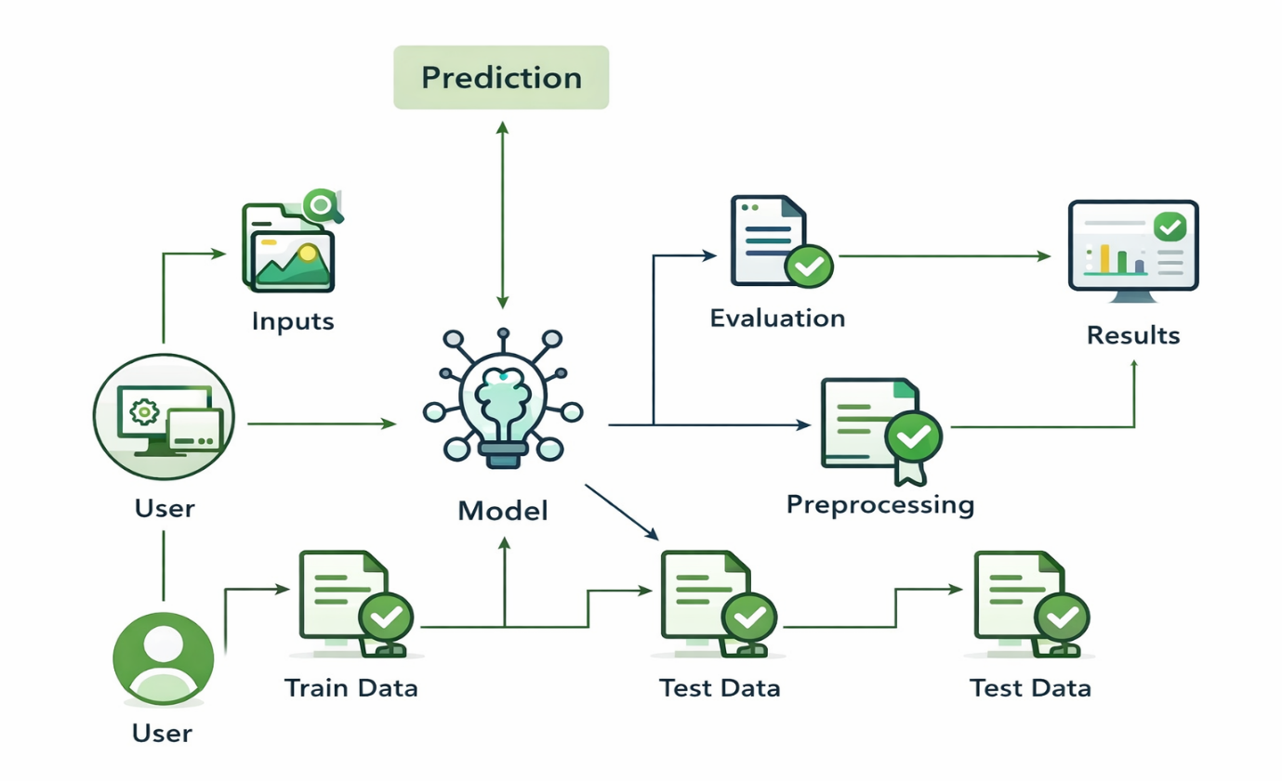

Prior Knowledge:
Deep Learning Frameworks::
- Transfer Learning: https://towardsdatascience.com/a-demonstration-of-transfer-learning-of-vgg-convolutional-neural-network-pre-trained-model-with-c9f5b8b1ab0a
- VGG16: https://www.geeksforgeeks.org/vgg-16-cnn-model/
- Convolutional Neural Networks (CNNs): https://www.analyticsvidhya.com/blog/2021/05/convolutional-neural-networks-cnn/ s://www.javatpoint.com/k-nearest-neighbor-algorithm-for-machine-learning
- Overfitting and Regularization: https://www.analyticsvidhya.com/blog/2021/07/prevent-overfitting-using-regularization-techniques/
- Optimizers: https://www.analyticsvidhya.com/blog/2021/10/a-comprehensive-guide-on-deep-learning-optimizers/
- Flask Basics: https://www.youtube.com/watch?v=lj4I_CvBnt0

Project Flow
- The user interacts with the UI (User Interface) to choose the image.
- The chosen image is analyzed by the model which is integrated with the flask application.
- Once the model analyses the input the prediction is showcased on the UI
To accomplish this, we have to complete all the activities listed below,
- Data Collection: Collect or download the dataset that you want to train.
- Data pre-processing
  - Data Augmentation
  - Splitting data into train and test
- Model building
  - Import the model-building libraries
  - Initializing the model
  - Training and testing the model
  - Evaluating the performance of the model
  - Save the model
- Application Building
  - Create an HTML file
  - Build python code
Project Structure
Create the Project folder which contains files as shown below
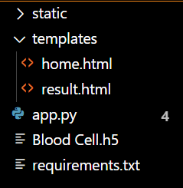

Activity 1.1: Importing the libraries:
Import the necessary libraries as shown in the image.
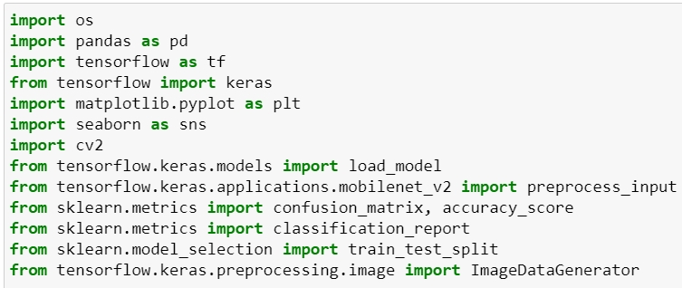
Data Visualization
The provided Python code imports necessary libraries and modules for image manipulation. It selects a random image file from a specified folder path. Then, it displays the randomly selected image using IPython's Image module. This code is useful for showcasing random images from a directory for various purposes like data exploration or testing image processing algorithms.

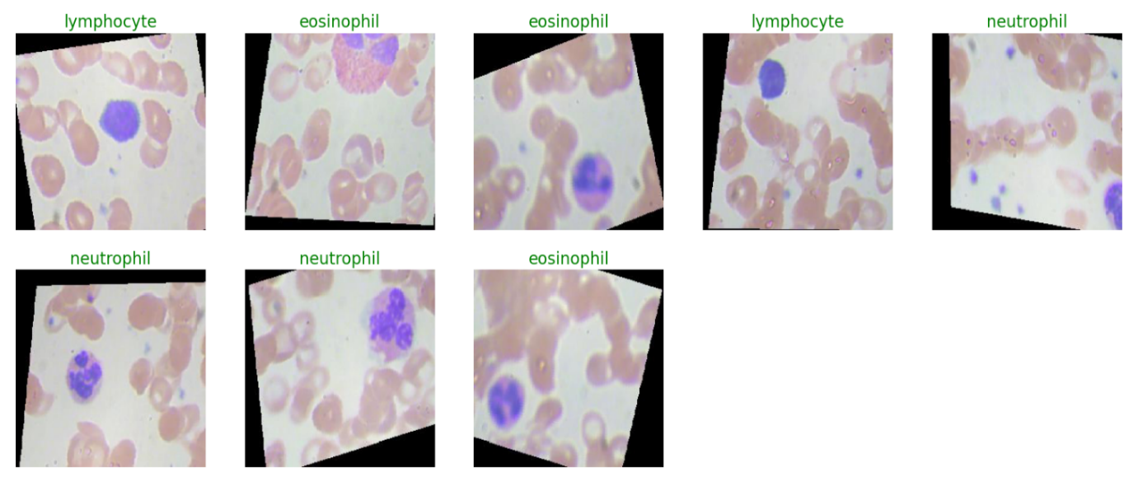
Data Augmentation
Data augmentation is a technique commonly employed in machine learning, particularly in computer vision tasks such as image classification, including projects like the BloodCells Classification . The primary objective of data augmentation is to artificially expand the size of the training dataset by applying various transformations to the existing images, thereby increasing the diversity and robustness of the data available for model training. This approach is particularly beneficial when working with limited labeled data.
Split Data and Model Building
Train-Test-Split:
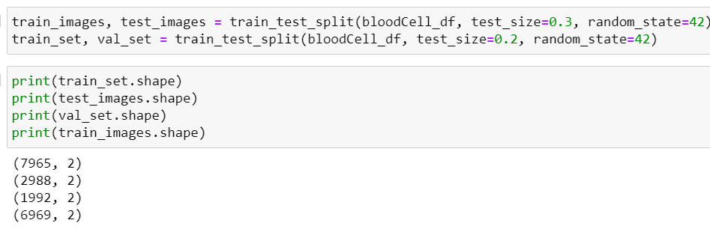
In this project, we have already separated data for training and testing.

Model Building:
Mobilenet V2 Transfer-Learning Model:
The MobileNetV2-based neural network is created using a pre-trained MobileNetV2 architecture with frozen weights. The model is built sequentially, incorporating the MobileNetV2 base, a flattening layer, dropout for regularization, and a dense layer with SoftMax activation for classification into four categories of blood cells. The model is compiled using the Adam optimizer and categorical cross-entropy loss. During training, which spans 5 epochs, a generator is employed for the training data, and validation is conducted with callbacks such as Model Checkpoint and Early Stopping. The best-performing model is saved as "blood_cell.h5" for future use. The model summary provides an overview of the architecture, showcasing the layers and parameters involved.
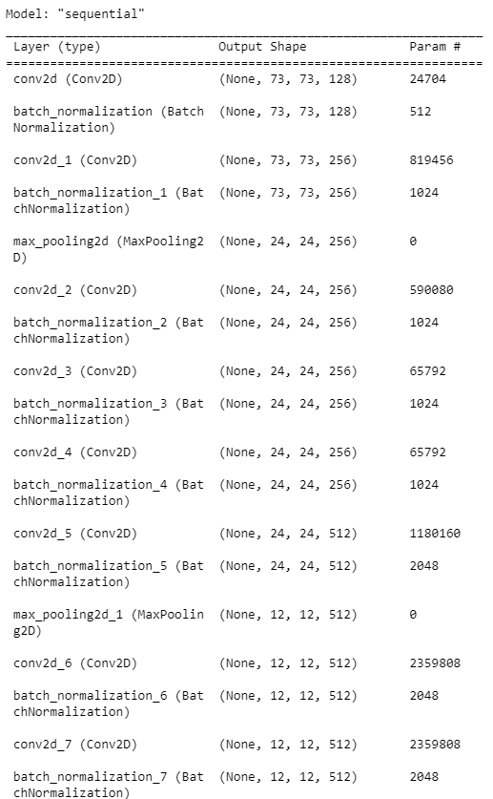

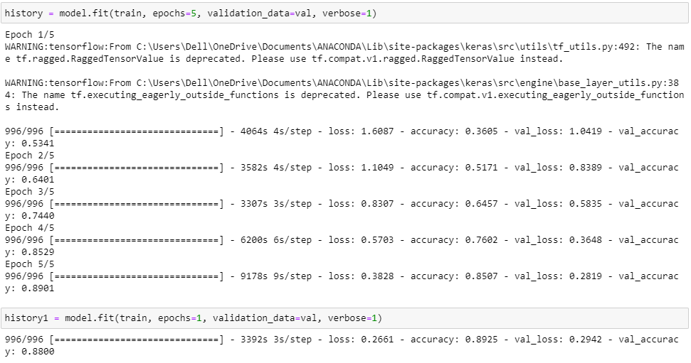
Testing Model & Data Prediction
Evaluating the model
Here we have tested with the Mobilenet V2 Model With the help of the predict () function.
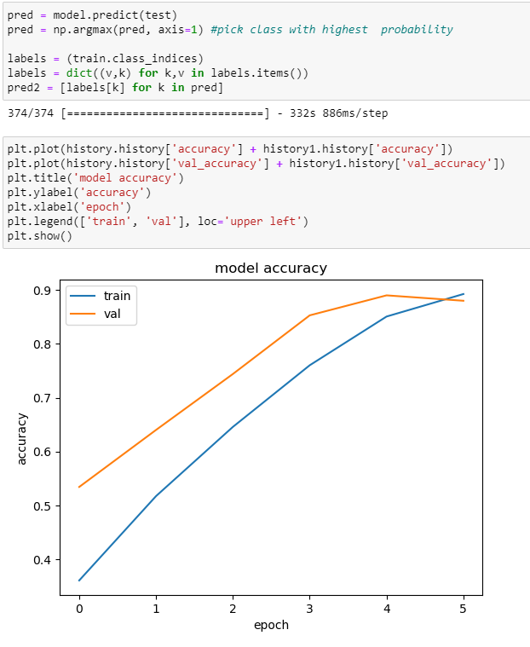

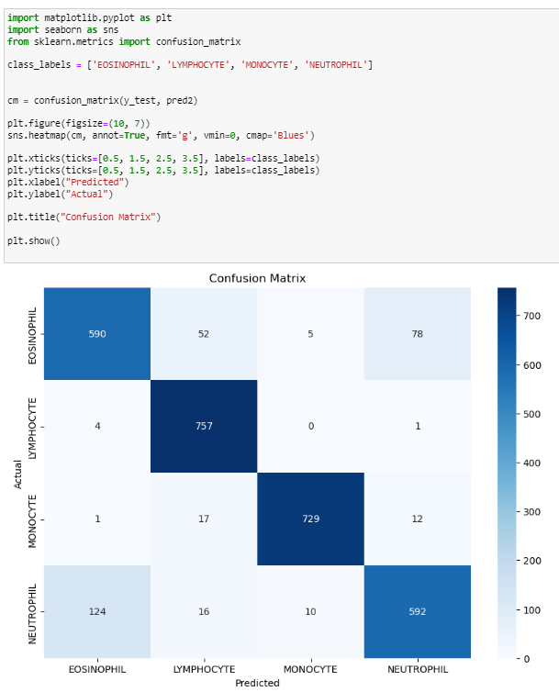
Saving the model
Saving the model
Finally, we have chosen the best model now saving that model.

Building HTML Pages:
For this project create three HTML files namely
- home.html
- result.html
Run the web application
- : Run the application
  - Open Anaconda prompt from the start menu
  - Navigate to the folder where your Python script is.
  - Now type the “app.py” command
  - Navigate to the local host where you can view your web page.
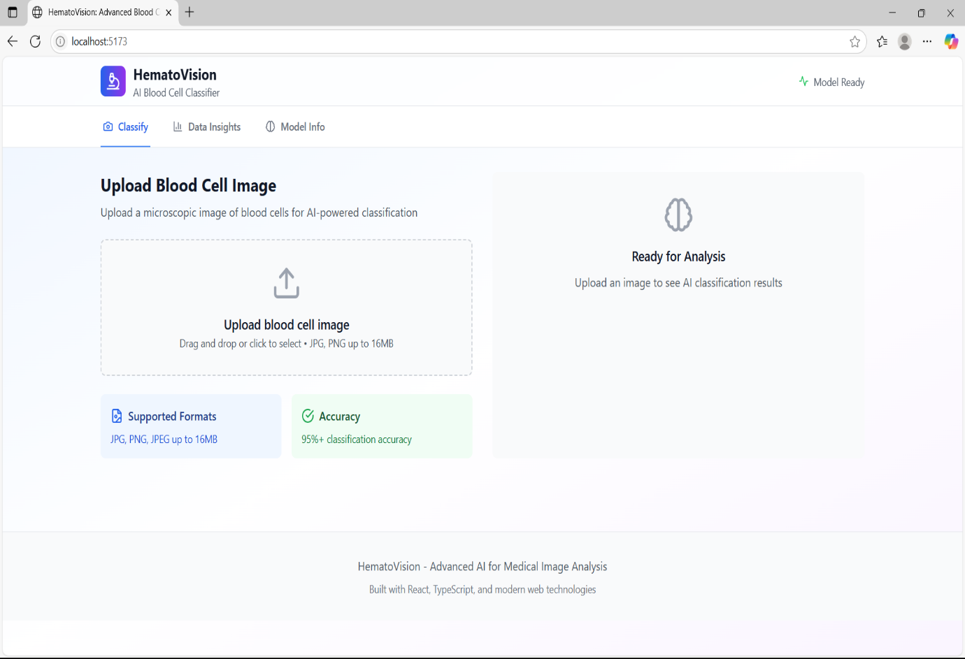
  - Click on the inspect button from the top right corner, enter the inputs, click on the predict button, and see the result/prediction on the web.

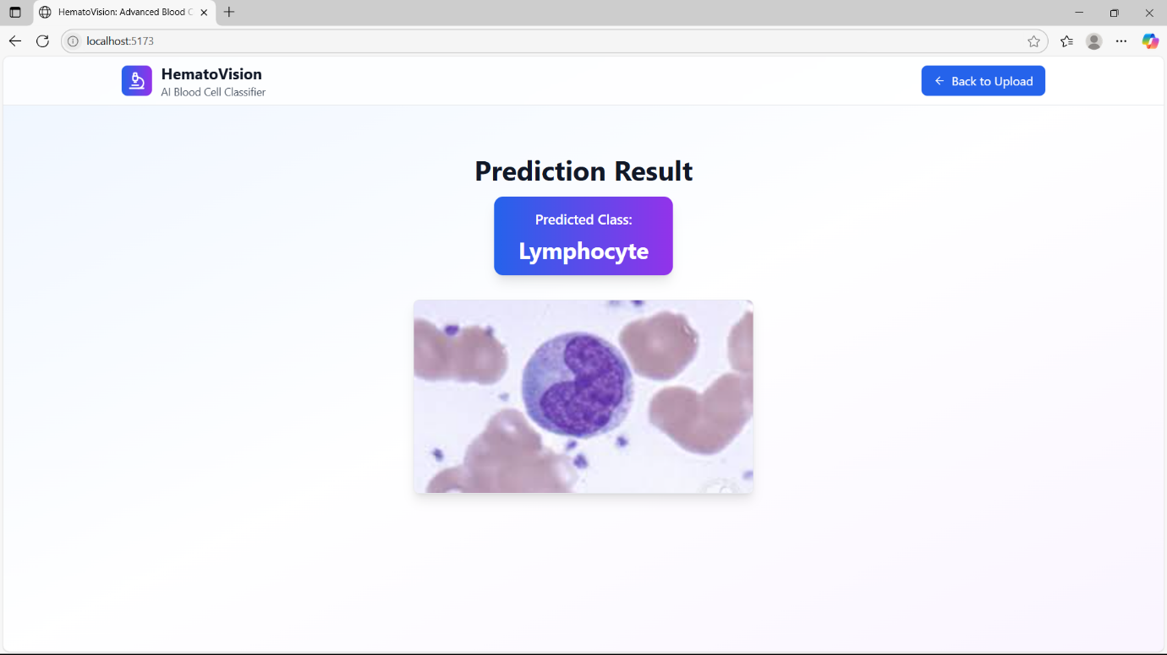

Project Objectives
By the end of this project, you will:
- Know fundamental concepts and techniques used for Deep Learning.
- Gain a broad understanding of data.
- Have knowledge of pre-processing the data/transformation techniques on outliers and some visualization concepts.

